**Project Report: E-Commerce Sales Analysis Report**

**1. Title**

E-Commerce Sales Report .

The objective of this project is to analyze and visualize the sales data of popular Indian e-commerce platforms like Amazon, Flipkart, Myntra, etc., to derive meaningful insights about order distribution, customer demographics, and sales performance.

# Tools Used

* Excel - For data cleaning, transformation, and dashboard creation
* Power Pivot & Charts - For dynamic visualization and pivot-based analysis
* Data Source - Microsoft Simulated e-commerce data (Orders, Gender, Region, Products, etc.)

# Dataset Description

Order ID ? Unique ID for each order

Customer ID ? Unique ID for each customer

Customer Name ? Name of the customer

Gender ? Gender of customer (Men/Women/Transgender)

Age ? Age of customer

Age Group ? 20+, 40+ classification

Order Date ? Date of order placement

Month ? Month of order

Platform ? E-commerce site (Amazon, Flipkart, etc.)

Product Category ? Category of product ordered

Quantity ? Number of units ordered

Amount ? Total order amount

Ship State ? State where order was delivered

# Dashboard Features

The dashboard includes the following visuals:

* Sales by Platform
* Top 5 Performing States
* Order Status Breakdown
* Gender & Age Distribution
* Men vs Women Sales
* Order vs Sales Analysis

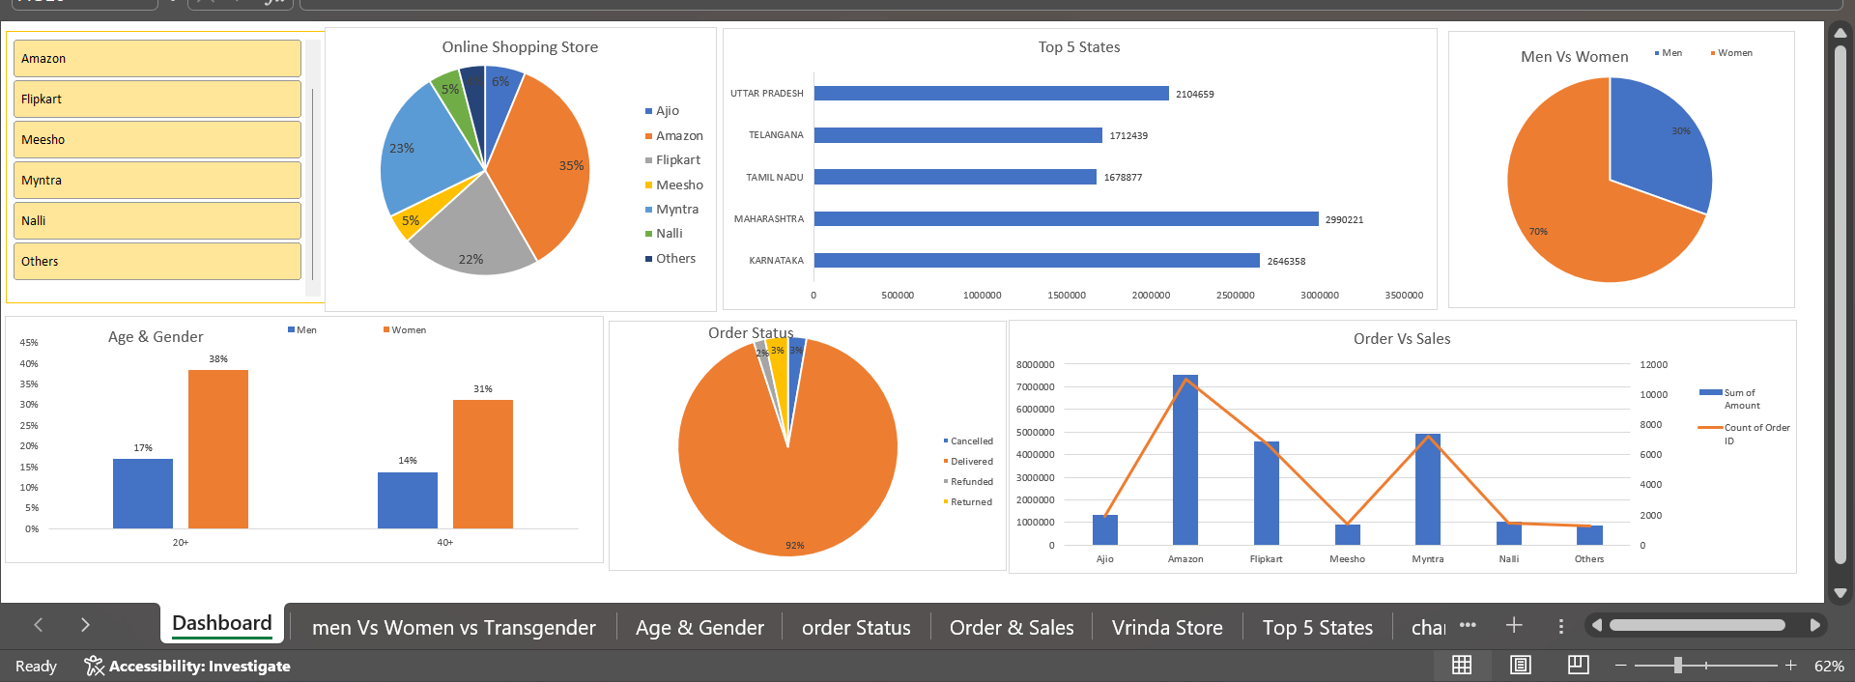

# Key Insights

* Amazon and Myntra contribute the highest to total sales.
* Most customers belong to the 20+ and 40+ age groups.
* Women customers represent 70% of the total order volume.
* Maharashtra, Karnataka, and Uttar Pradesh are top-performing states.
* Delivered orders make up 92% of total orders, with a small percentage being refunded or cancelled.

# Conclusion

The dashboard offers valuable insights into customer behavior, regional performance, and sales trends. It can help businesses better understand which platforms and demographics drive the most revenue and adjust marketing or logistics strategies accordingly.

# Future Scope

* Integrate with real-time MySQL data using Python.
* Use Power BI or Tableau for more dynamic visualizations.
* Perform customer lifetime value and churn analysis.

**Submitted by** -------

Name : Amit Kumar sah

Semester : 6th.

Domain : Data Analytics

ERP Id : 6602977

Group Name : G2